VPC (Virtual Private Cloud)

1. This window shows console home,

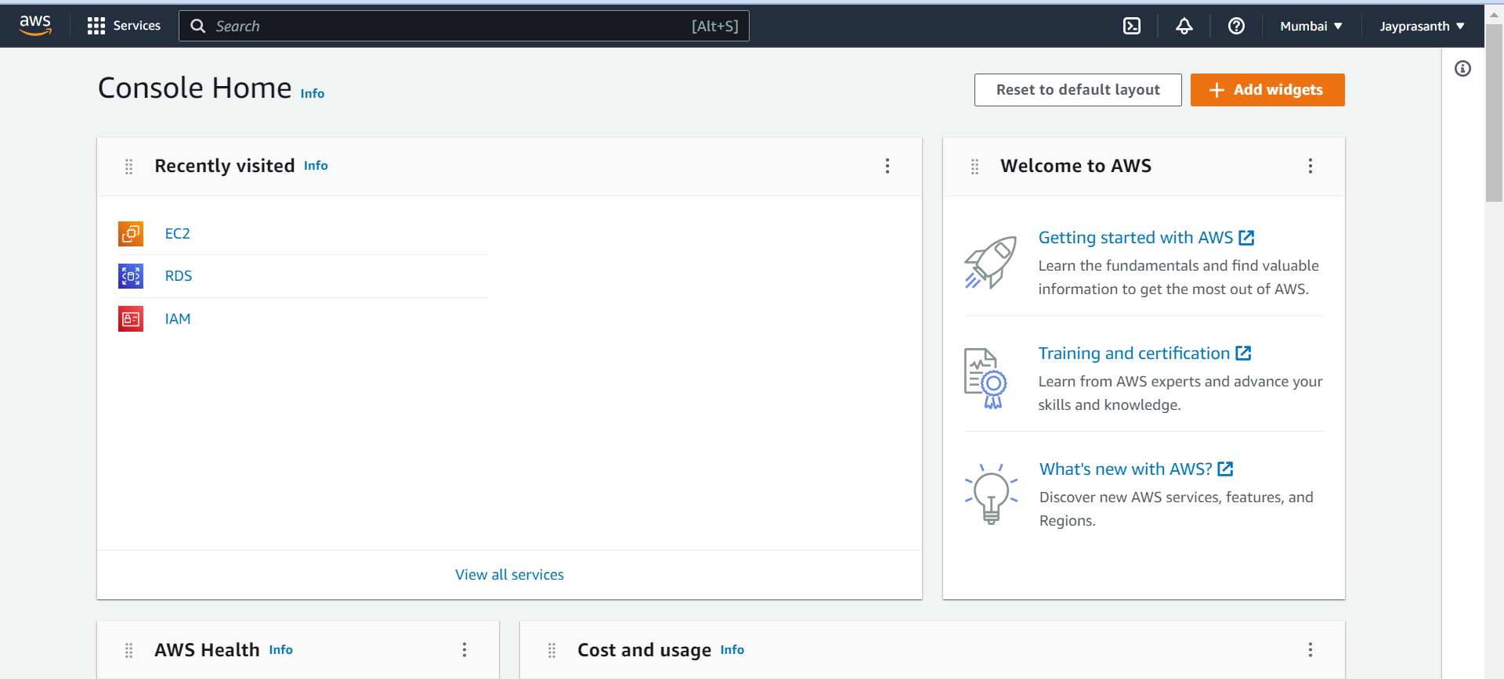

2. search VPC, and select VPC

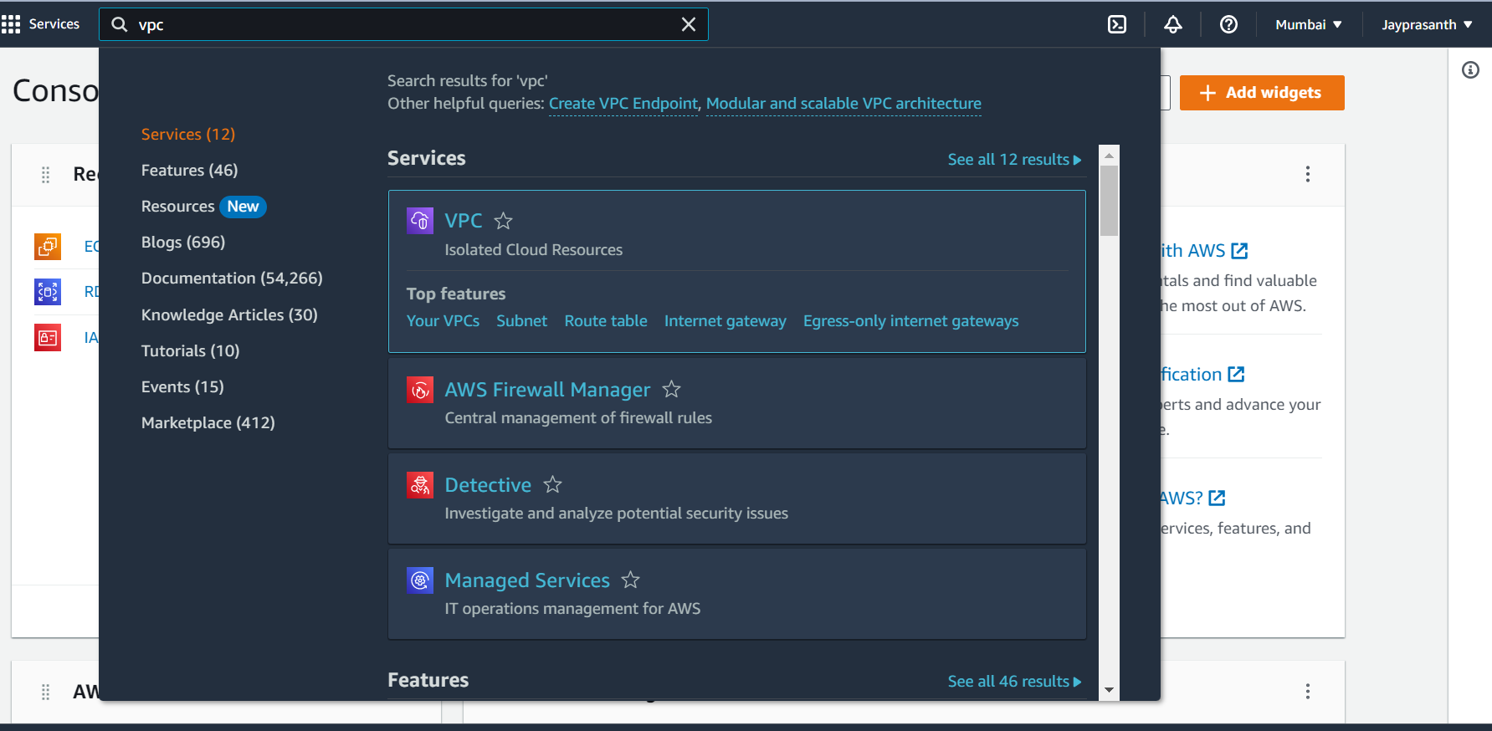

3.after select, VPC dashboard shown below

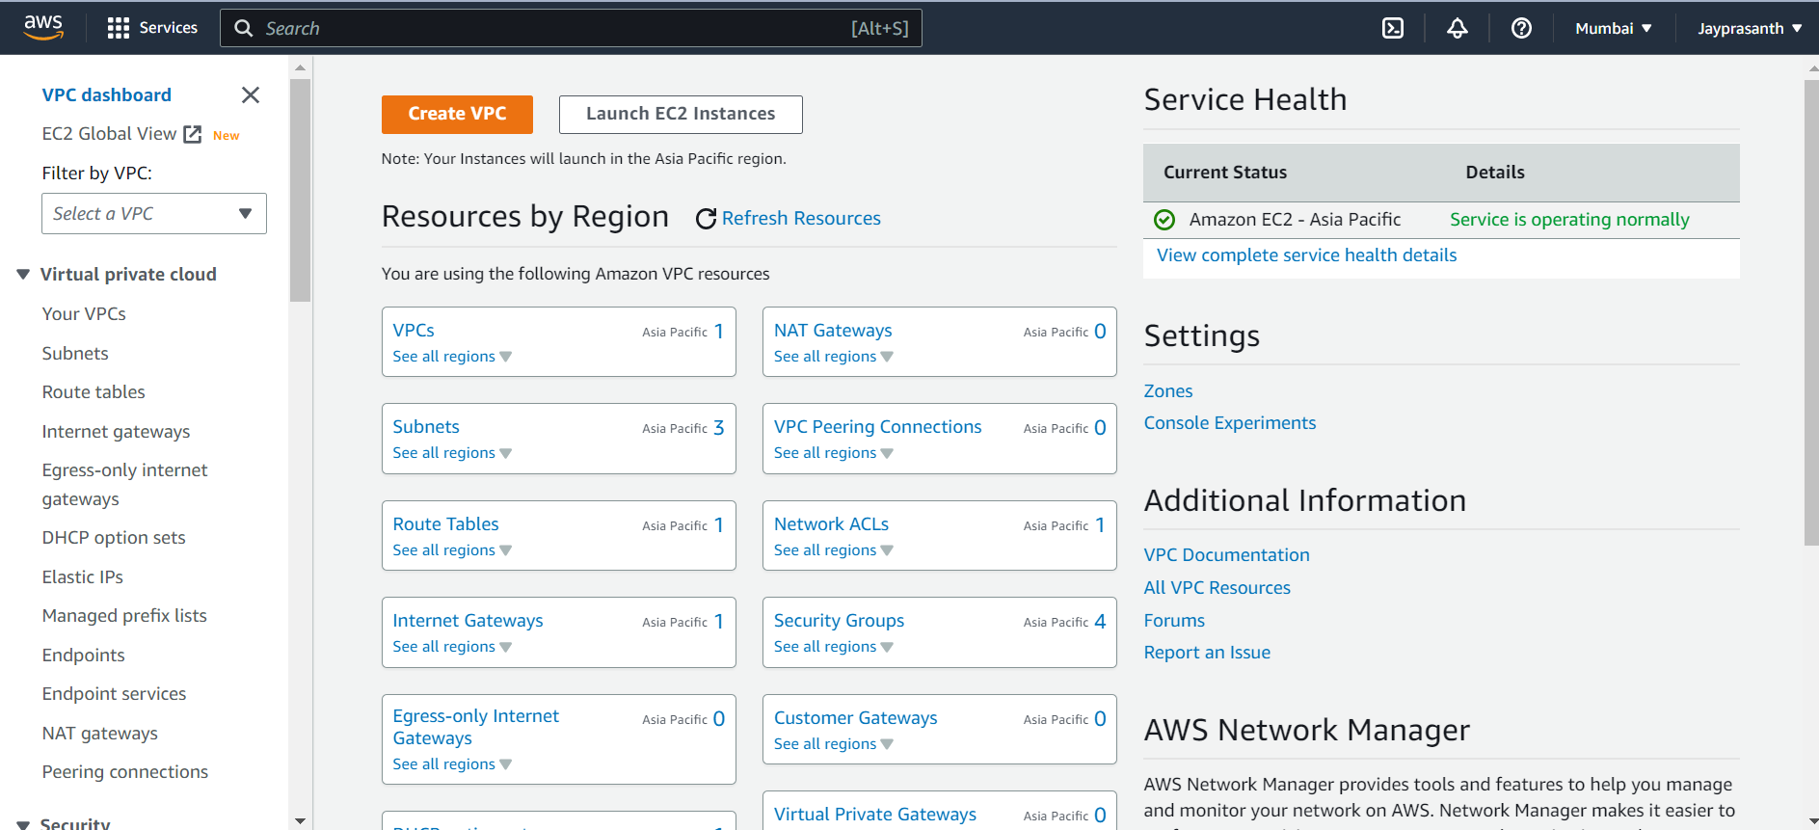

4.Click Create VPC,

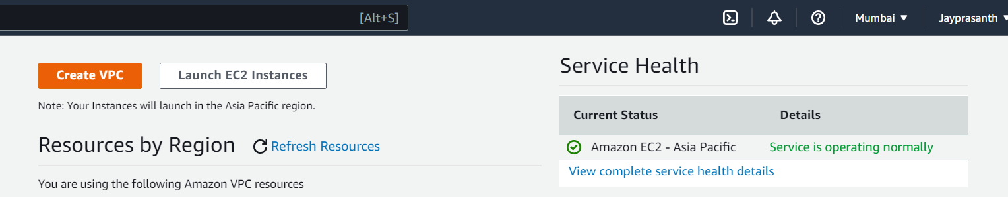

5.After that give VPC settings, choose VPC and more, if choose VPC only you need to give subnet, NAT gateway, route table, in other you don’t give default it allocates itself

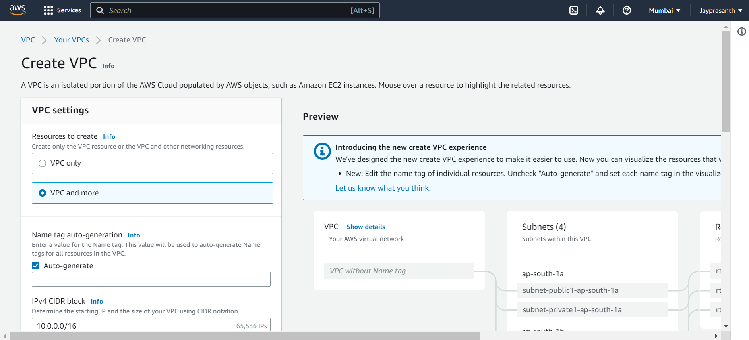

6.give Name to the VPC, choose 10.0.0.0/16, it allocates 65536 IPs to choose 16 for our VPC

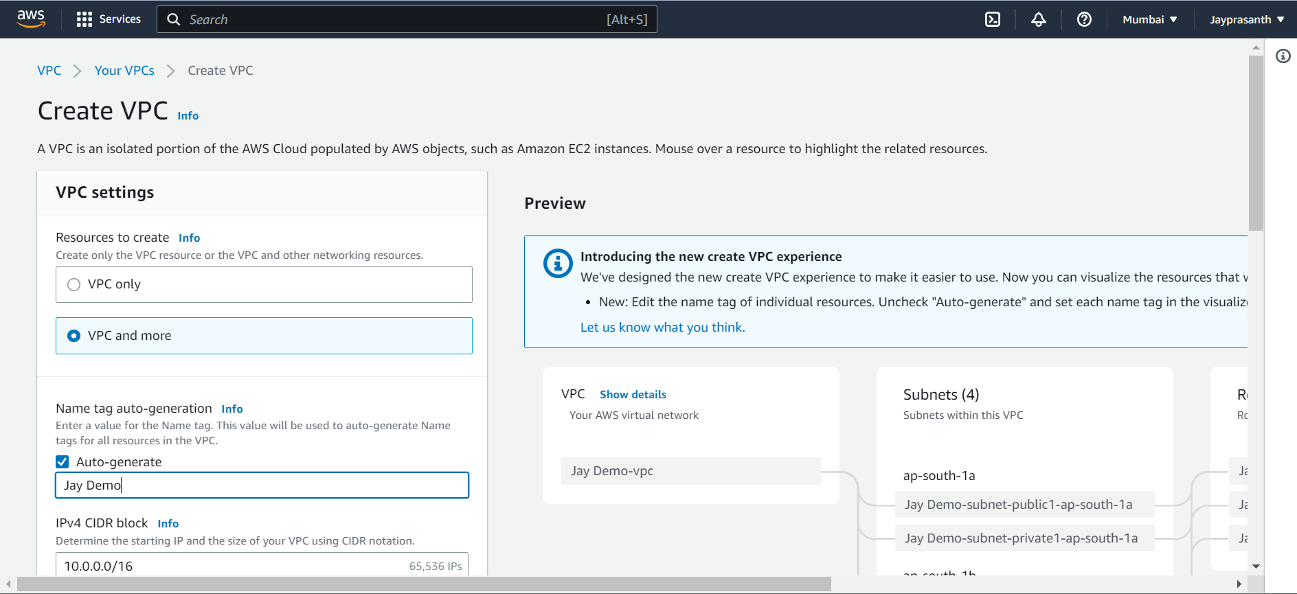

7. no. of availability zones, choose what you need, and public subnets and private subnet

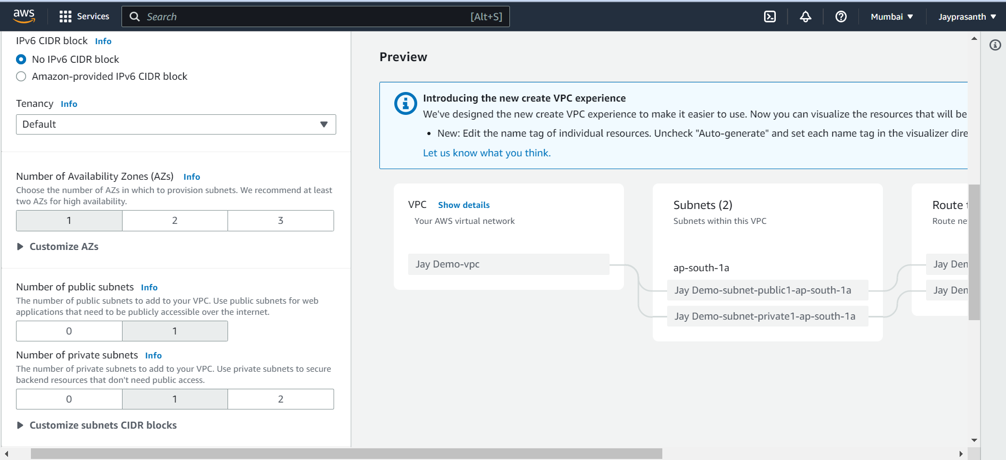

8.NAT gateways choose in 1 AZ and also VPC endpoints

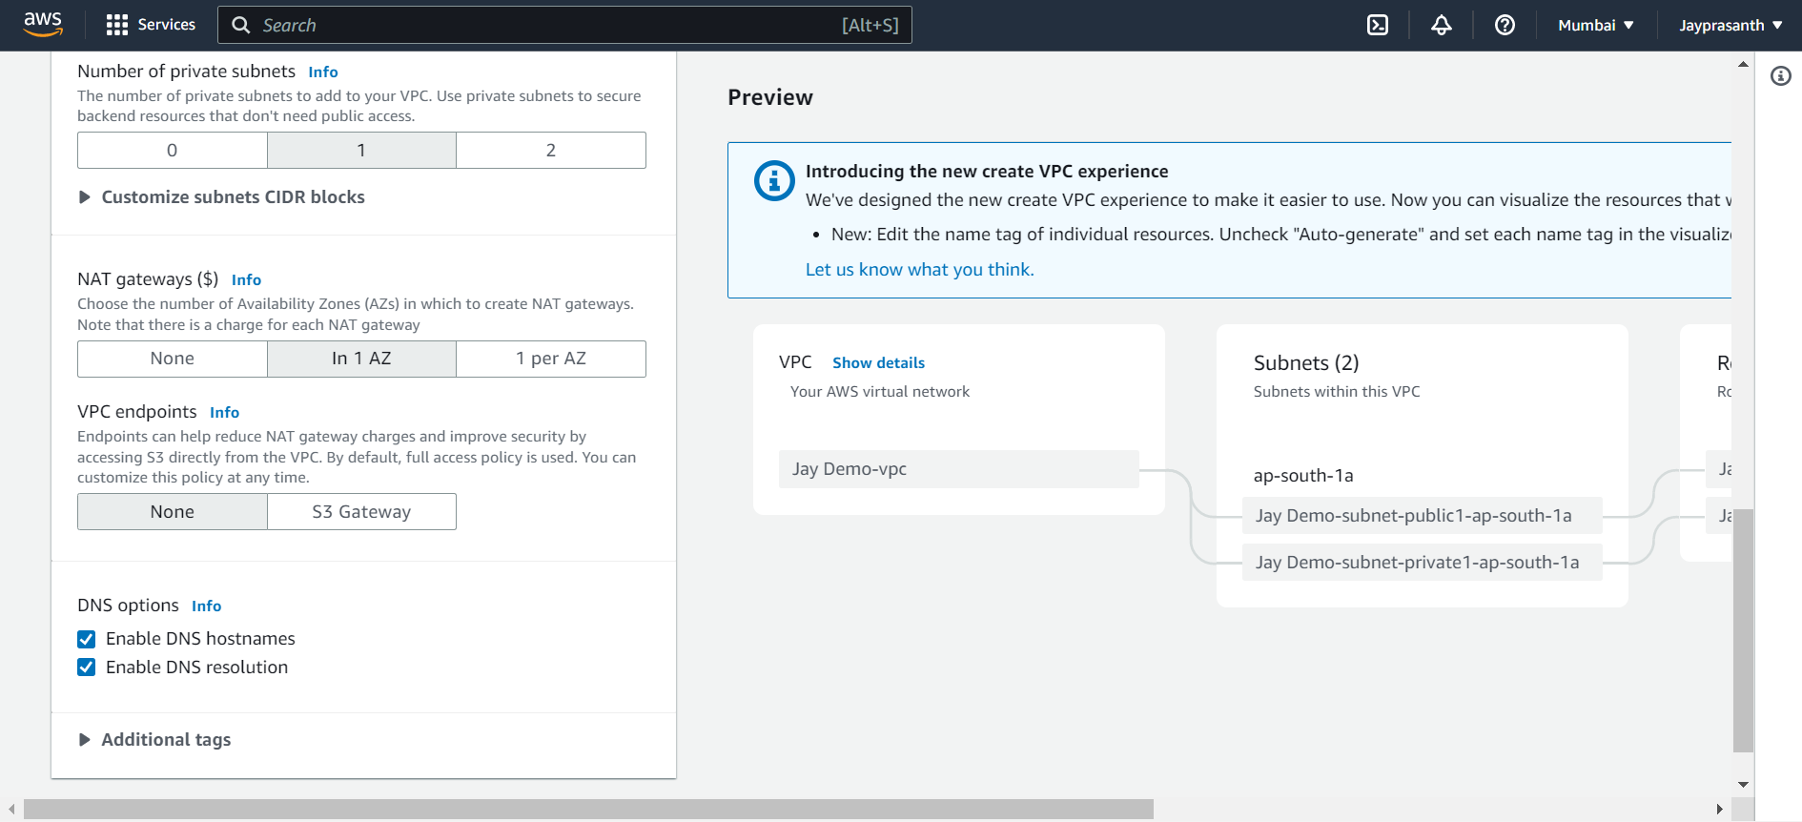

9.this window shows the flow of our VPC before creating

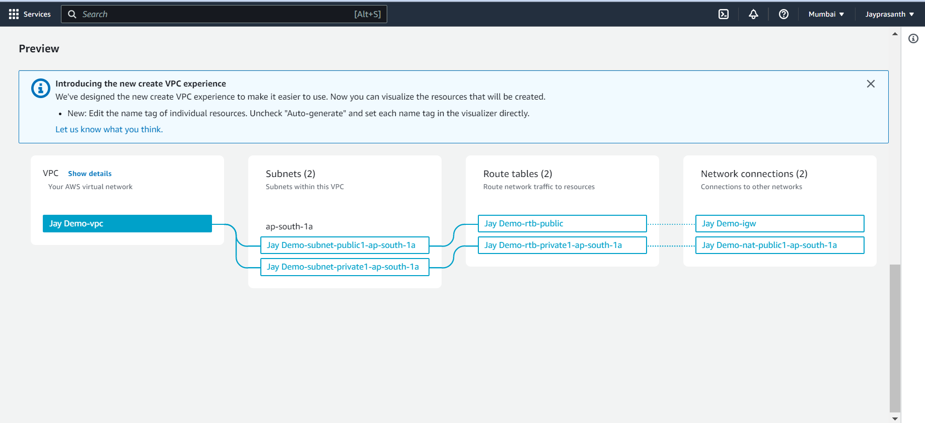

10.Loading....

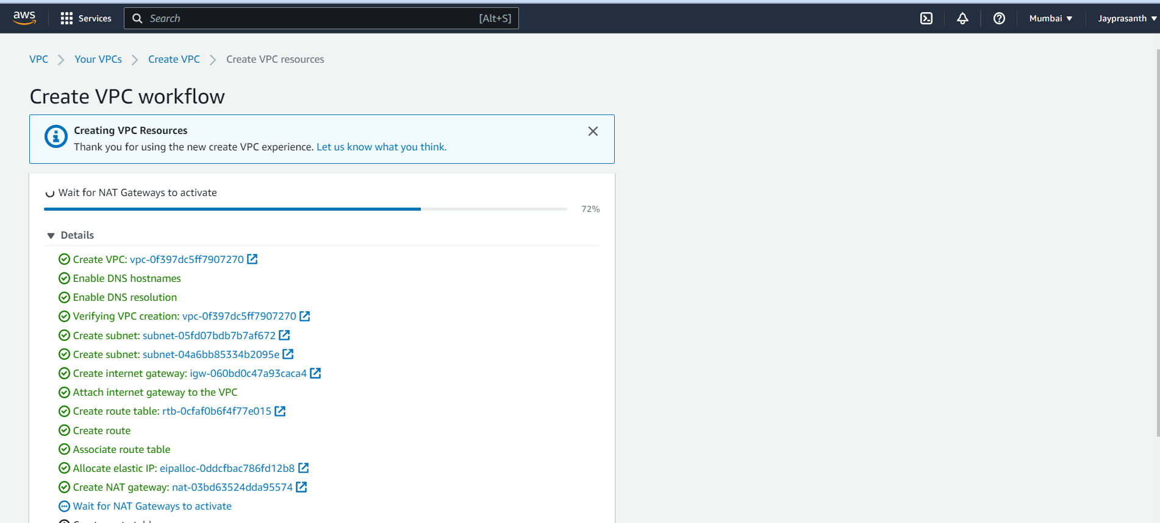

11.successfully created

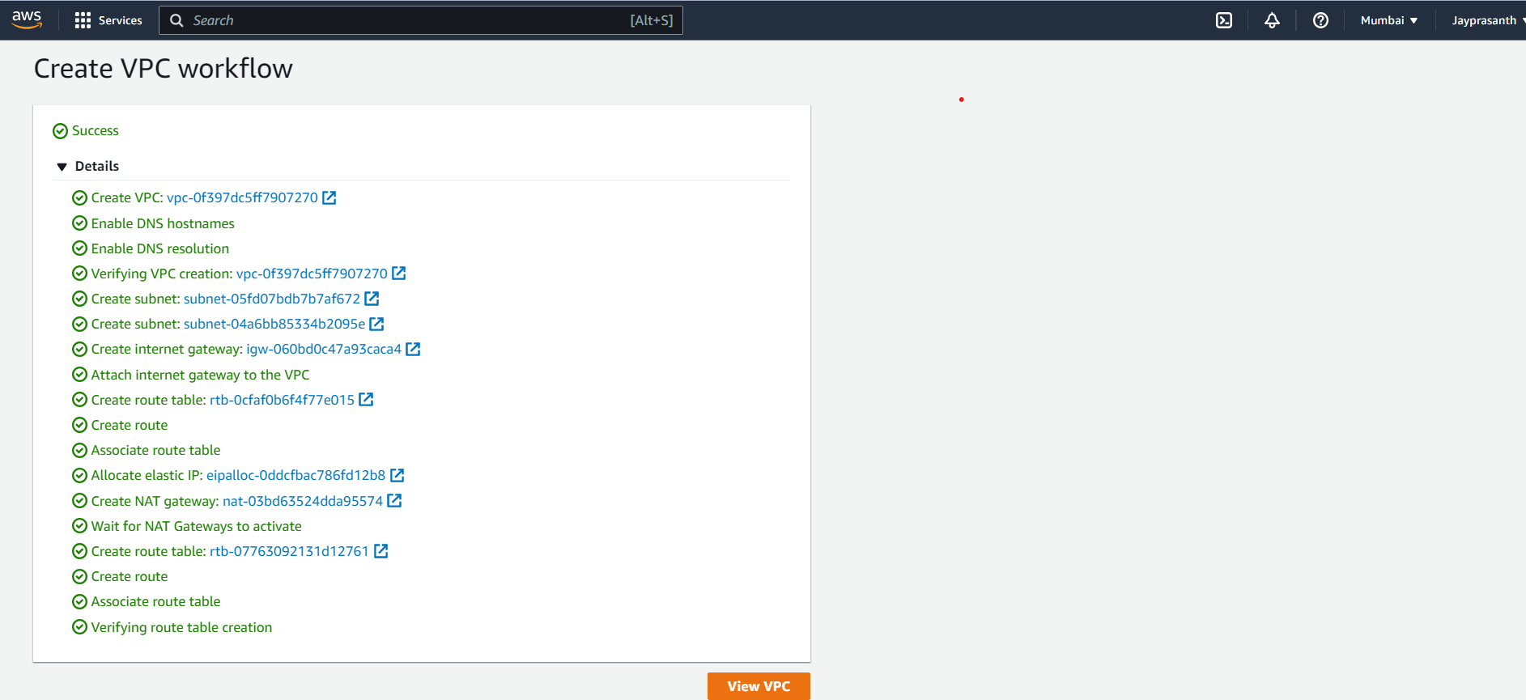

12.shows our VPC

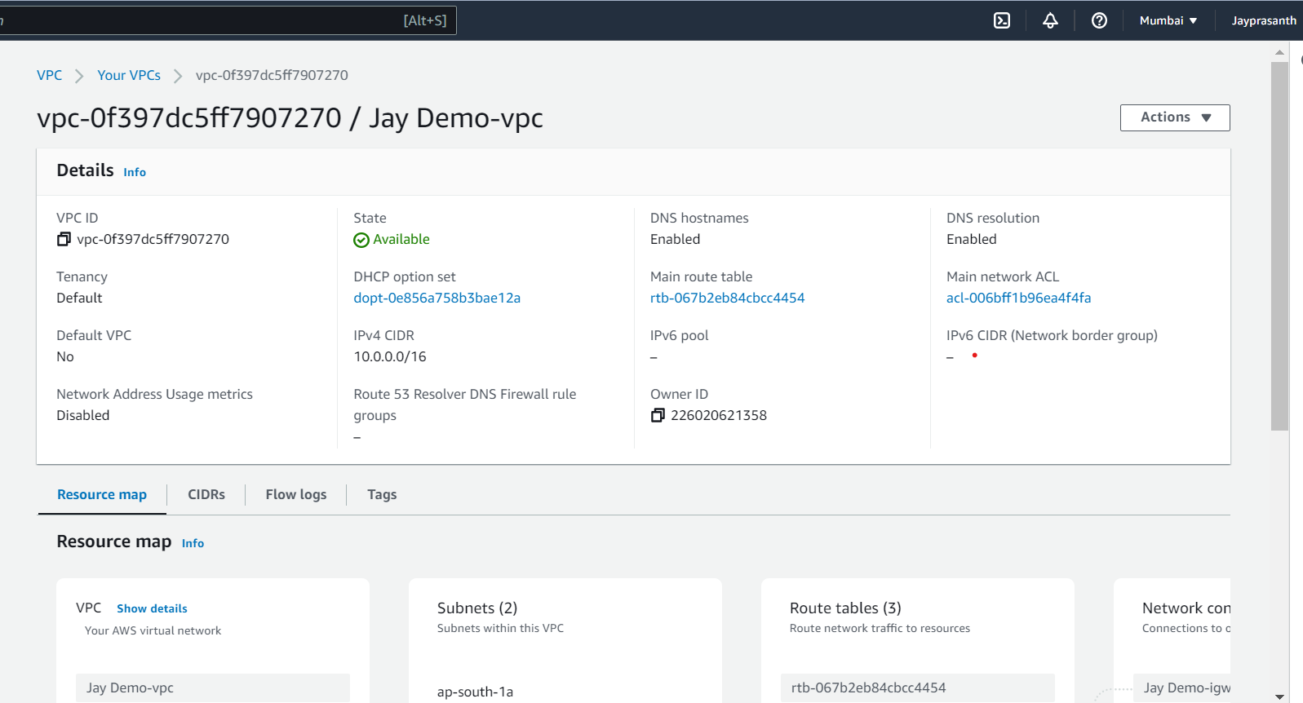

13.Subnets for our VPC

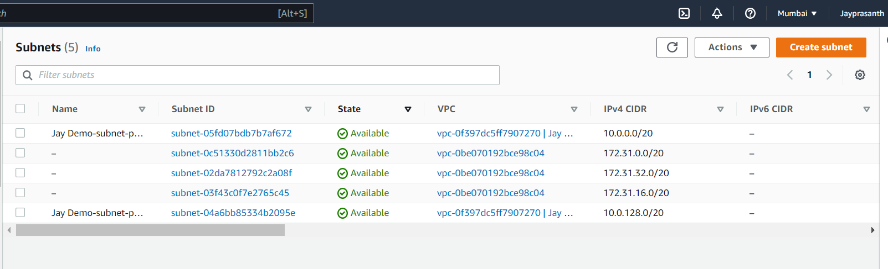

14.Routes Table

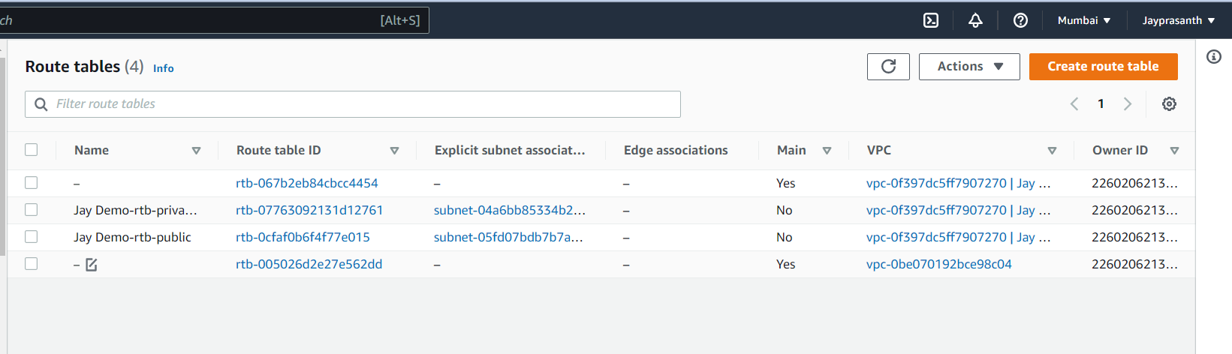

15.Internet Gateways

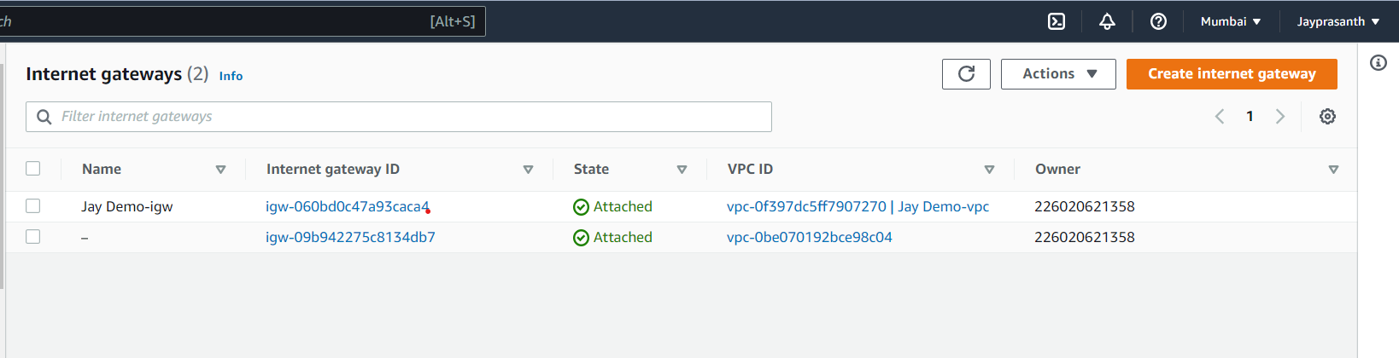

16.Elastic IP address, these are default created when we create our VPC

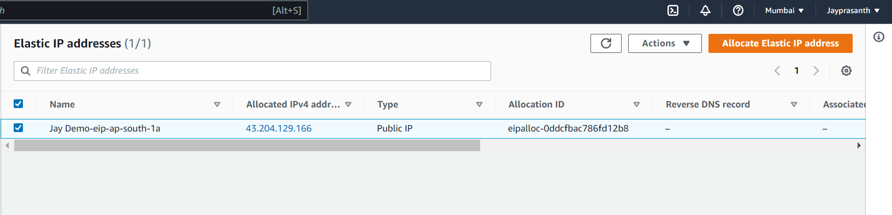

17.This shows, When Create Instance, choose network settings and open VPC and then show our created VPC

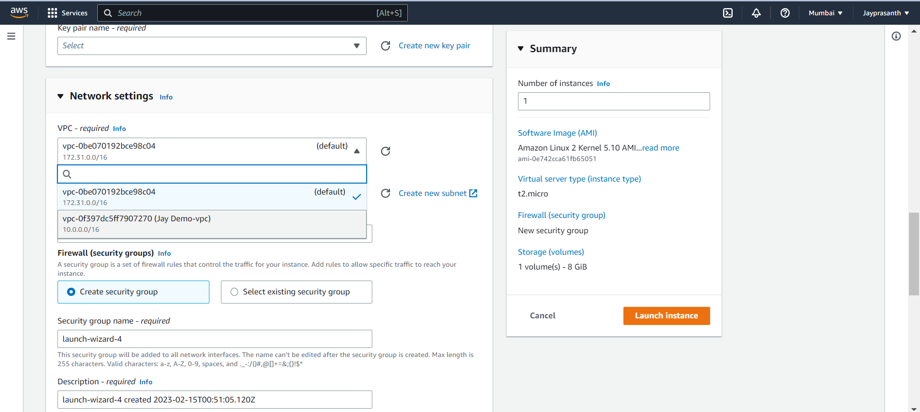

18.If we want to delete our VPC, We need to delete other connected items, Firstly Delete NAT gateways

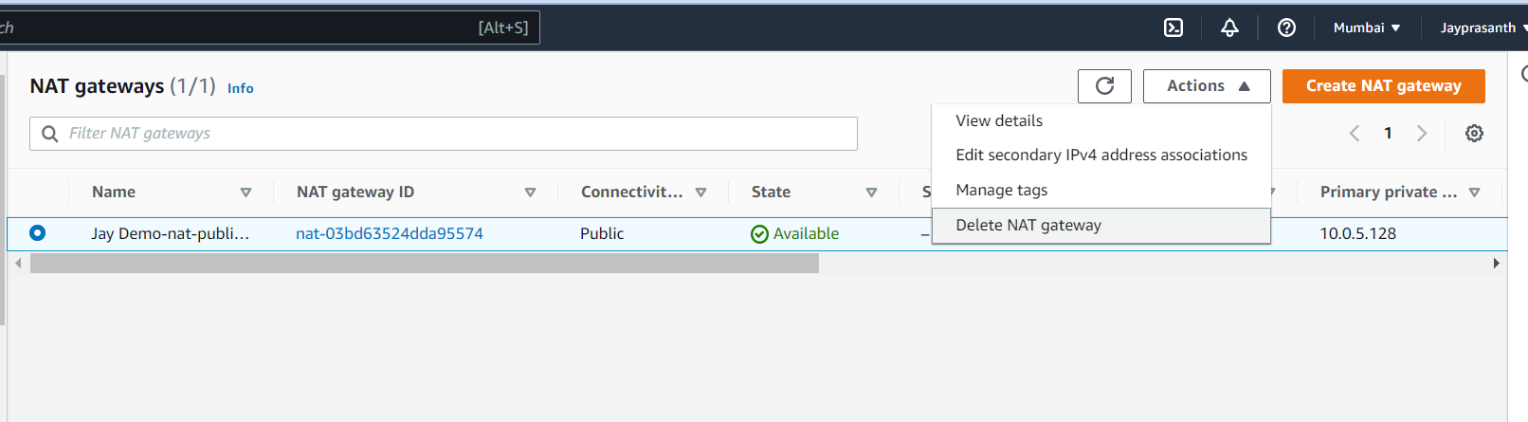

19.then delete

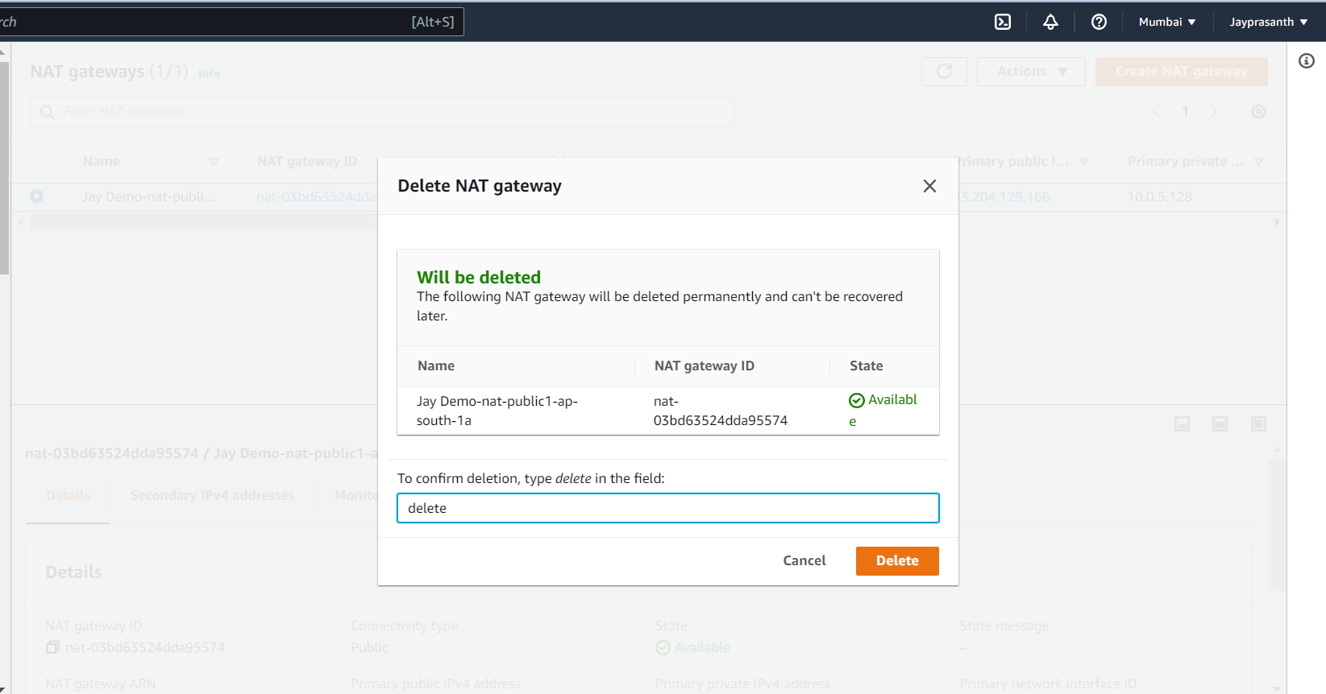

20.Second, Subnets of our VPC then select Actions --> Delete subnet

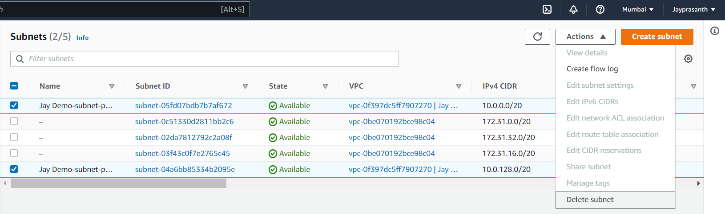

21.then delete type and delete

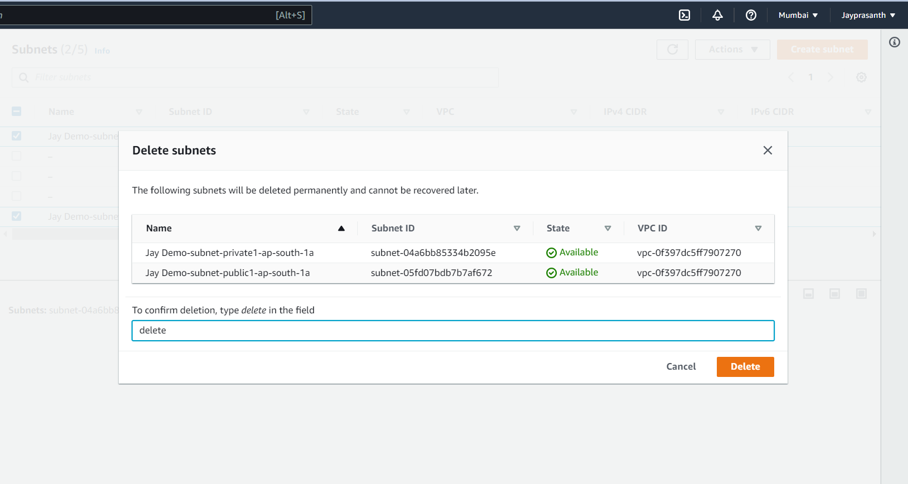

22.Third Route Table

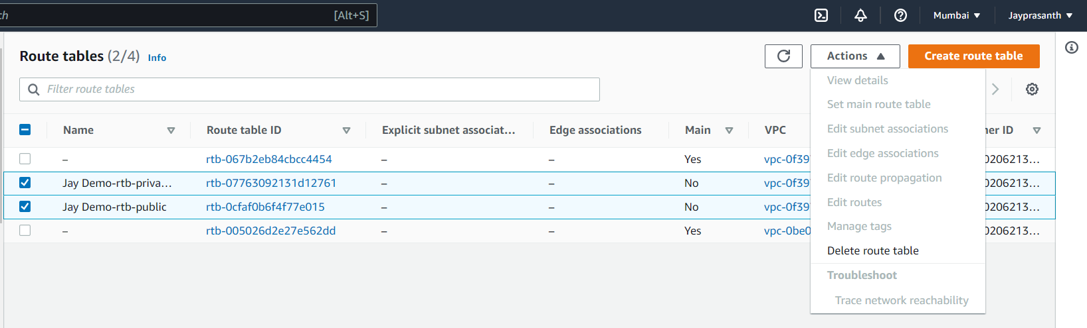

23.Type Delete to delete

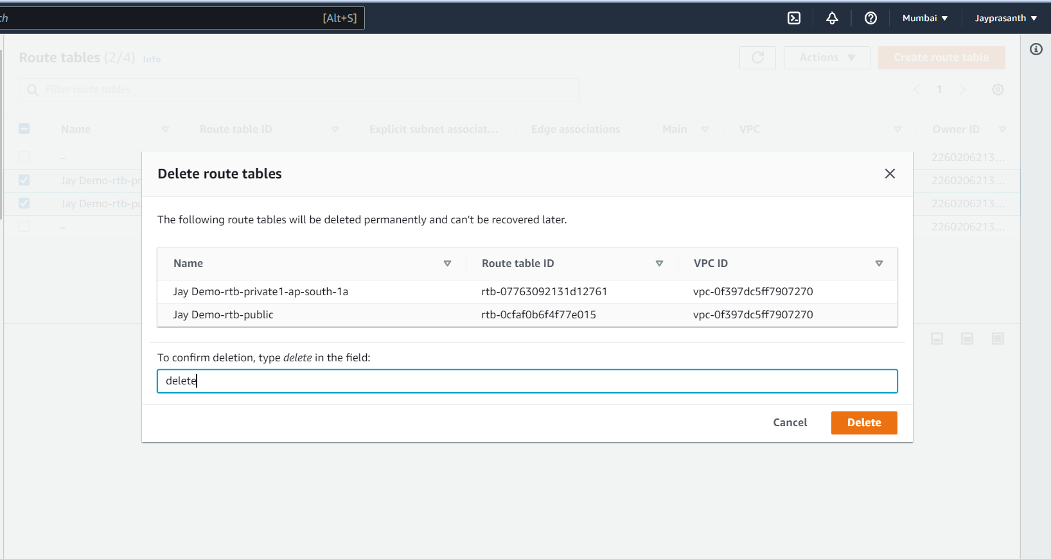

24.Fourth, Elastic IP need to delete, to delete Elastic IP click Release

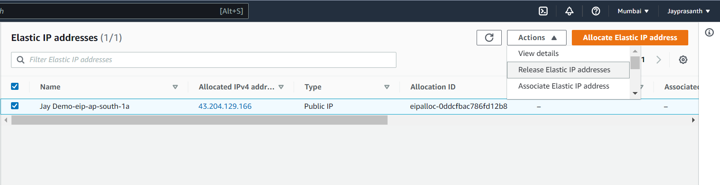

25.click release

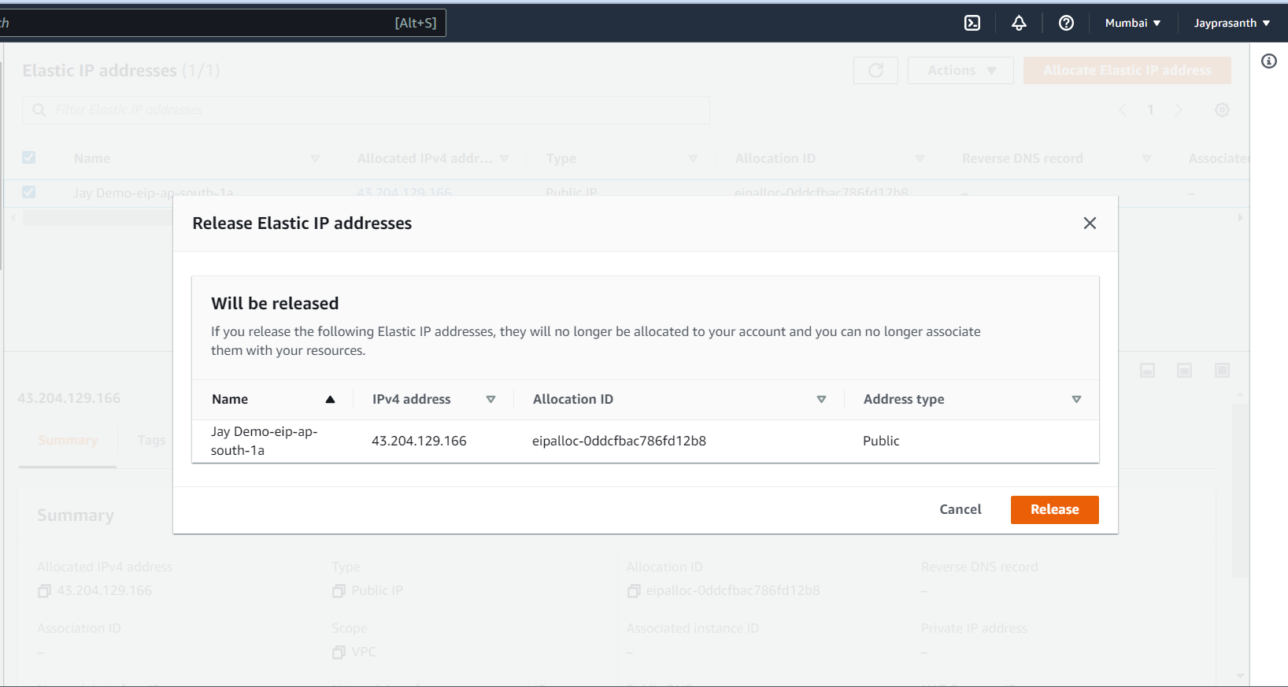

26.Fifth Internet Gateways, Actions --> Detach VPC first

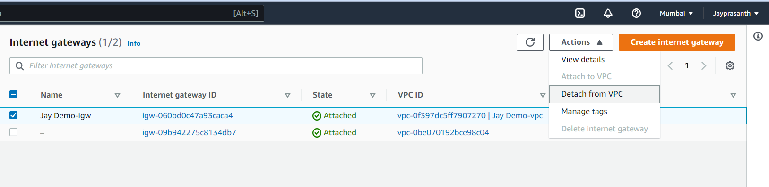

27.

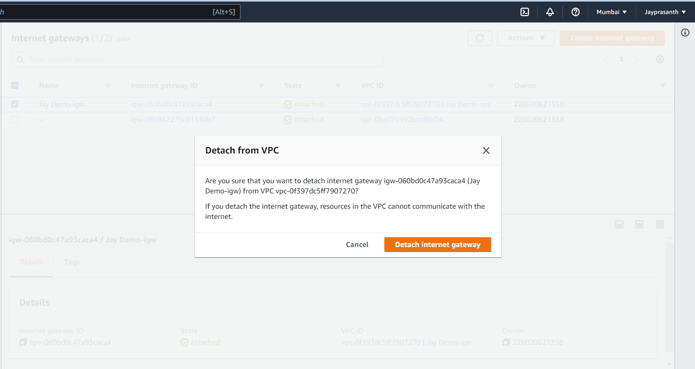

28.After Detach, Delete the Internet Gateways

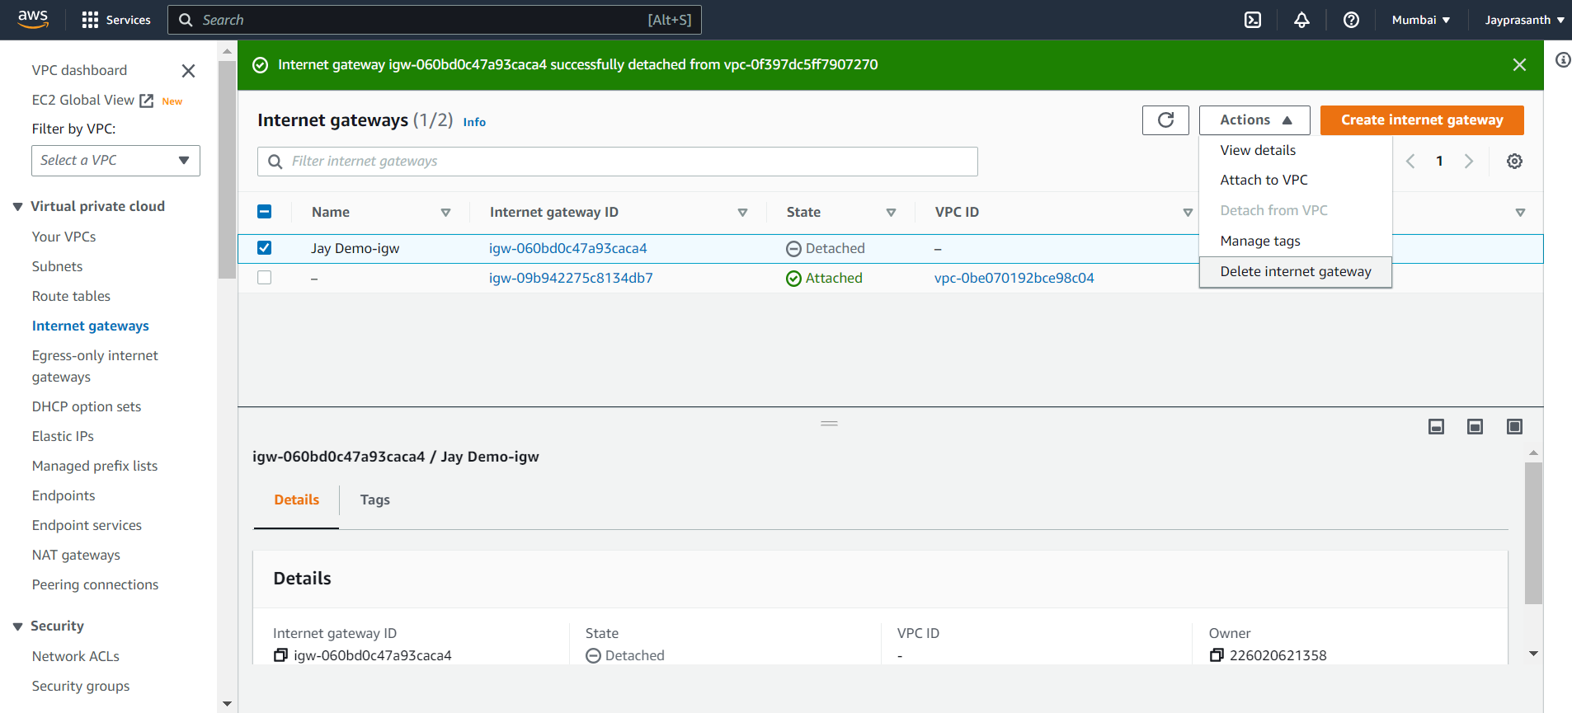

29.Type Delete

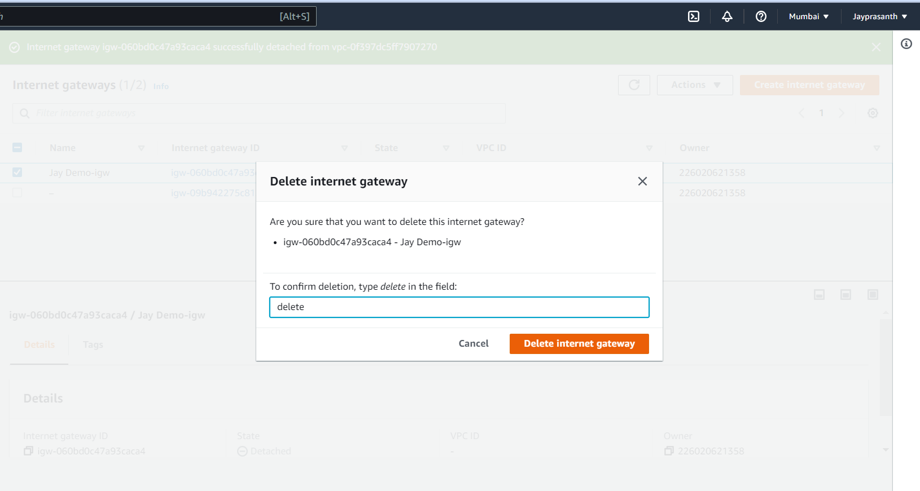

30.dashboard shows any left to delete

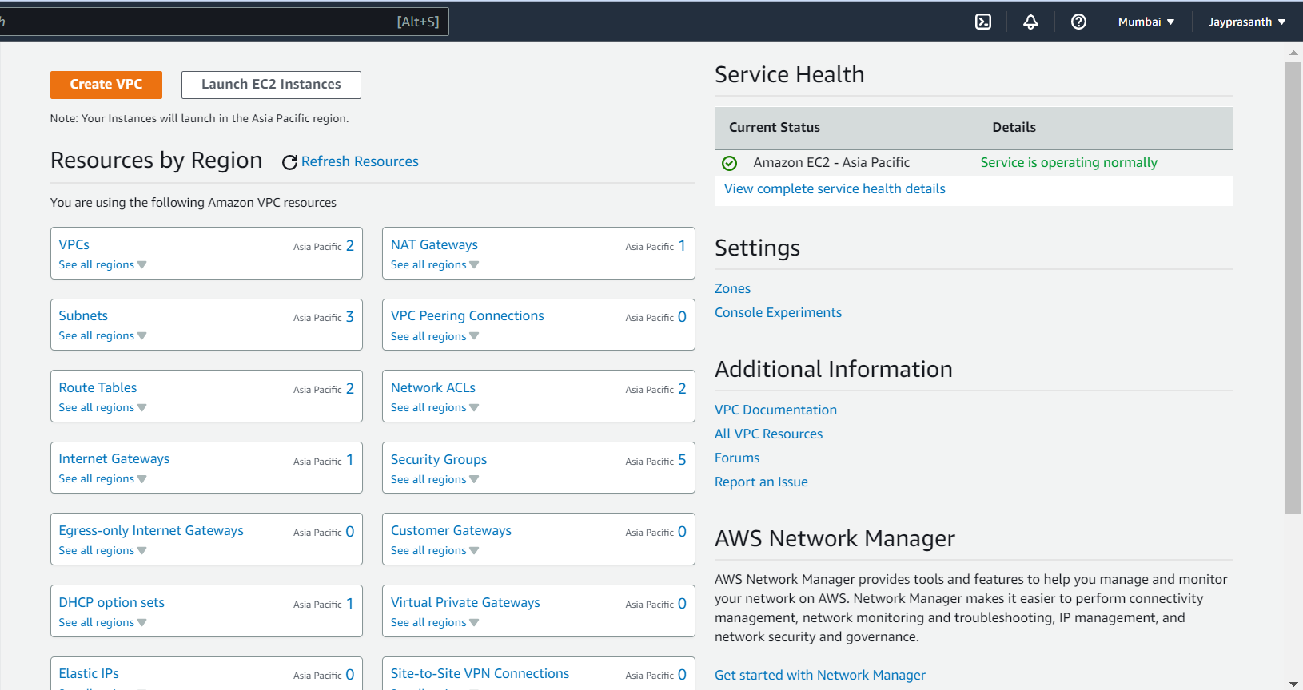

31. Then Lastly delete the VPC, click the checkbox and Actions --> Delete VPC

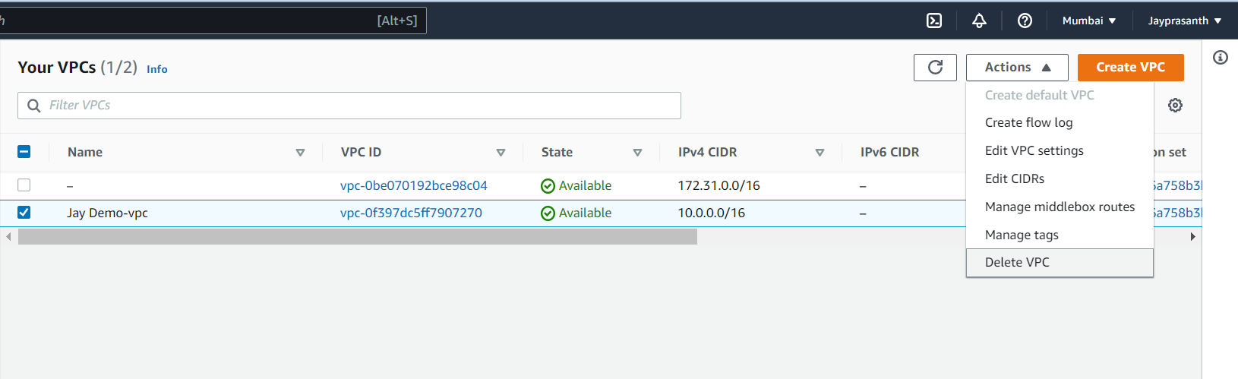

32.Type Delete

